Software Developments Toolbox
9466A | 6:00-7:00 MTH

GROUP 1

Topic 1 - Advanced Code Editing/Formatting
Topic 2 - Code Refactoring
Topic 3 - Testing
Topic 4 - Debugging
Topic 5 - Miscellaneous (Documentation)

Submitted by:
Bernardo, Laurence M.
Fongkot, Reden F.
Mahmood, Imran D.
Panopio, Russel Jacob L.
Siababa, Joshua A.

Submitted to:
Mr. Roderick Makil

TOPIC 1 - ADVANCED CODE EDITING/FORMATTING
Advanced Code Editing
Helps the developers in advance coding by providing tools and techniques to make their life a lot easier.
Template changing using Java Class
You can add you the name of the author of the program at the top also the date and some comments before the coding starts.
- You go to the tools templates.
- Find Java then choose Java Class and click Open editor.
- Now you can insert the author of the program and also the description, date and comment of the instructor.
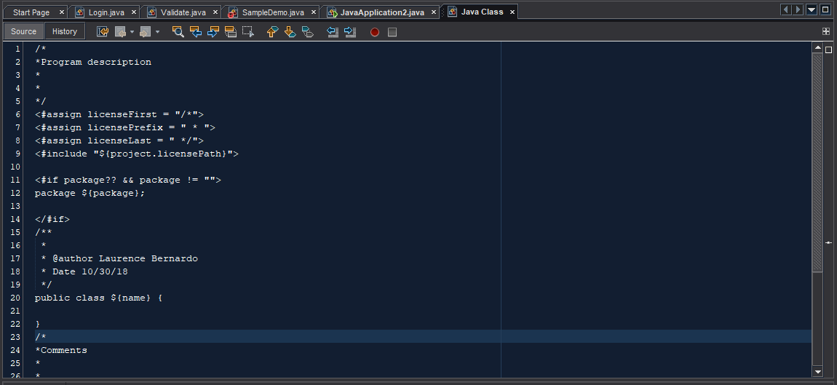
- Don’t forget to save, then open a new Java class.
Shortcuts Code from keyboard template.
There are a lot advantage using NetBeans IDE keyboards one of this is Keyboard Shortcuts.
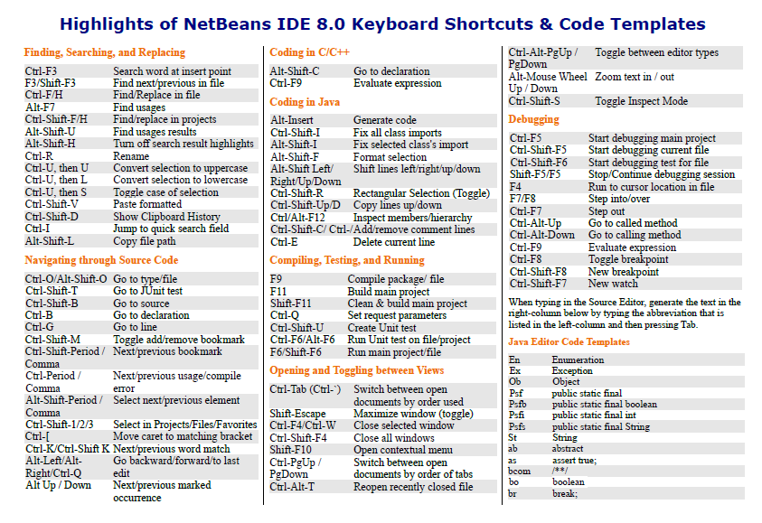
This Shortcut Keyboard is not available to other IDE’s.

Formatting Code in NetBeans
You can indent selected multiple lines of codes by pressing Tab or Alt+Shift+Right, and you can also reverse the indentation by pressing Shift+Tab or Alt+Shift+Left.
The editor toolbar has two buttons that can use for indenting and unindenting the selected multiple lines of codes.
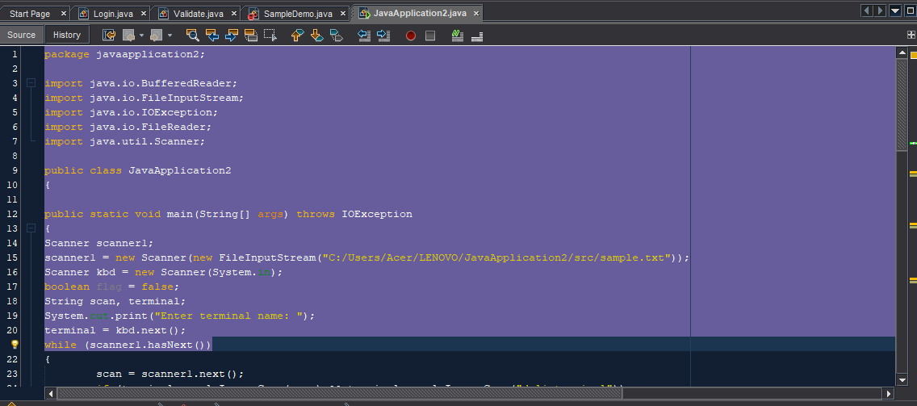

Changing Format Rules
For the file types that you created, you can adjust the files in the formatting settings, such as placement of curly braces, number of spaces per tab, and so on. To adjust formatting rules for your Java files:
- You go to the tools menu, find the options and click the editor button in the left panel.
- Click editor button.
- You can choose in the different categories.
- For my demo I will choose Tabs and Indents.
- Adjust the properties for the indention tab engine to your taste then click Ok to App.
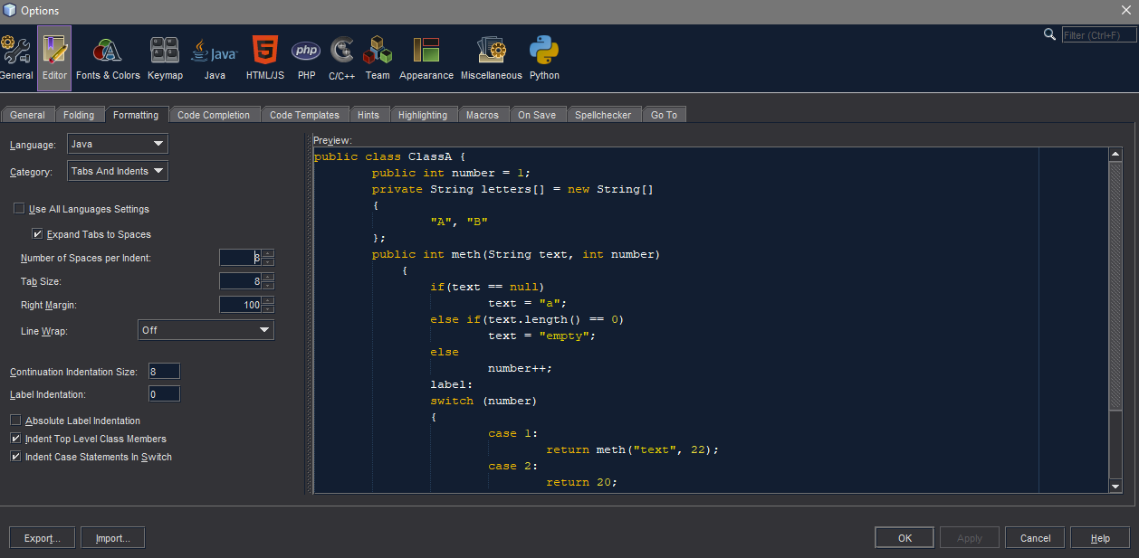
- You must reformat each file to the new rules by opening the file that you create and pressing Ctrl+Shift+F.

TOPIC 2 - CODE REFACTORING
Refactoring is the process of altering the design and structure of a code, but without changing its functionalities. Factoring is done “little by little”. With each every small step, excess and unneeded codes are removed or eliminated, and in return, readability is enhanced and memory demand is reduced. Enhanced readability does not only allow for a better understanding of the code, but results to easier modification as well.

Refactoring Using Eclipse IDE

Refactoring: Extracting a Method
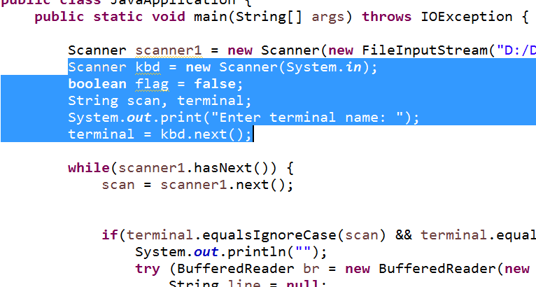
This refactoring technique transforms a block of code into a method. This will prevent code duplication, making your program shorter and allowing better readability, understanding, and maintainability.
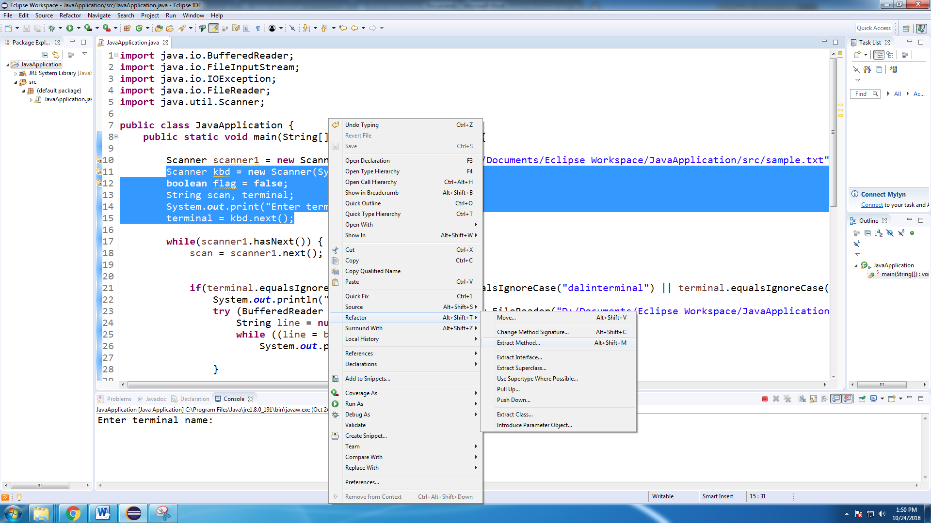
Highlight the block of code which you want to transform into a method. In this demonstration, the block of code that asks/takes input from the user is selected.

Right-click while the codes are highlighted to see available options. Go to “Refactor”, or simply do the keyboard shortcut Alt+Shift+T, and choose “Extract Method”. Alternatively, you can directly go to this refactoring technique by typing the keyboard shortcut Alt+Shift+M. You will then be prompted to type a name for the method.
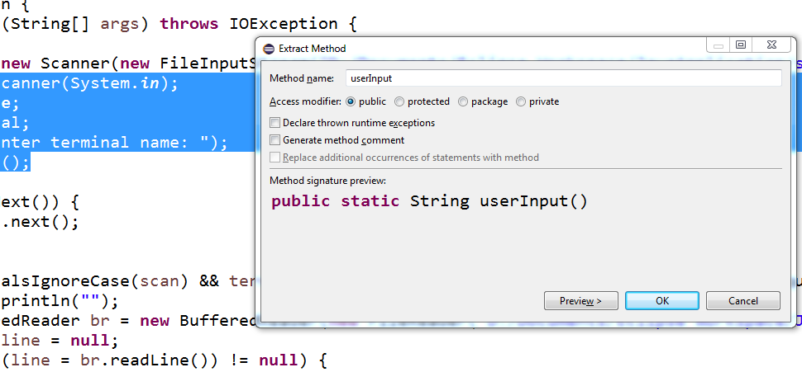
Clicking on “OK” will now extract the block of code that was chosen into a method.
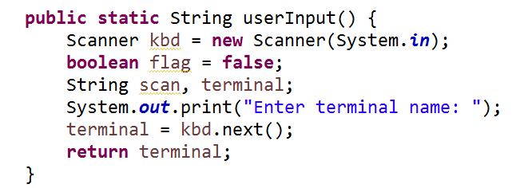

Refactoring: Inline Method
The opposite of extract method is inline method.
Highlight the name of the method that you wish to refactor. Go to the refactoring options, then choose “Inline…”. In Eclipse IDE, the keyboard shortcut for inline method is Alt+Shift+I.

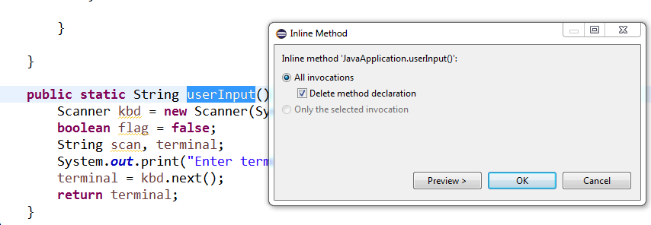
Using inline method, the userInput() method that was created using the extract method technique was more or less reverted back to its original form.

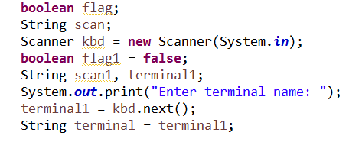

Refactoring: Renaming
Renaming is probably the most used refactoring technique. This technique can be very useful in a large program where variables and methods are used multiple times.

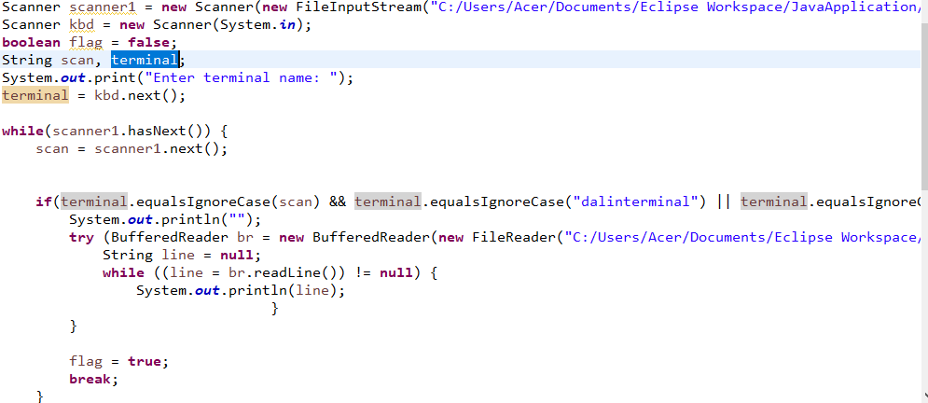
Highlight the name of the variable/method which you wish to rename. Right-click and choose “Rename…” in the refactoring options, or directly go to this refactoring technique using the keyboard shortcut Alt+Shift+R.

Choose a new name for the variable/method that you wish to rename. This will also automatically update all instances in which that certain variable/method has been called within your program.
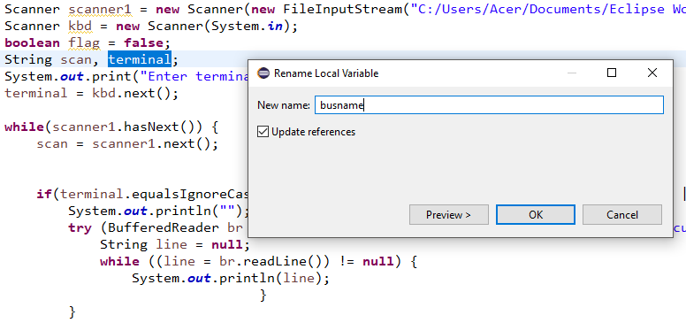

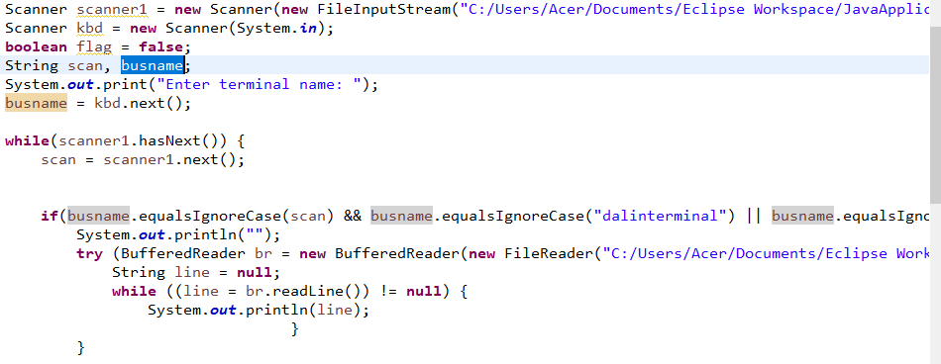

TOPIC 3 - TESTING

TOPIC 4 - DEBUGGING
Debugging using NetBeans

Programmers use debugging tools like NetBeans to help identify problems in a program and to easily fix the programs’ issue.

Breakpoints

• A point where the code will stop temporarily for user to analyze the code up till that point.
• To make a break point, click on the left side of the line. Upon doing so, a pink box will appear which would mean that a breakpoint has been made.
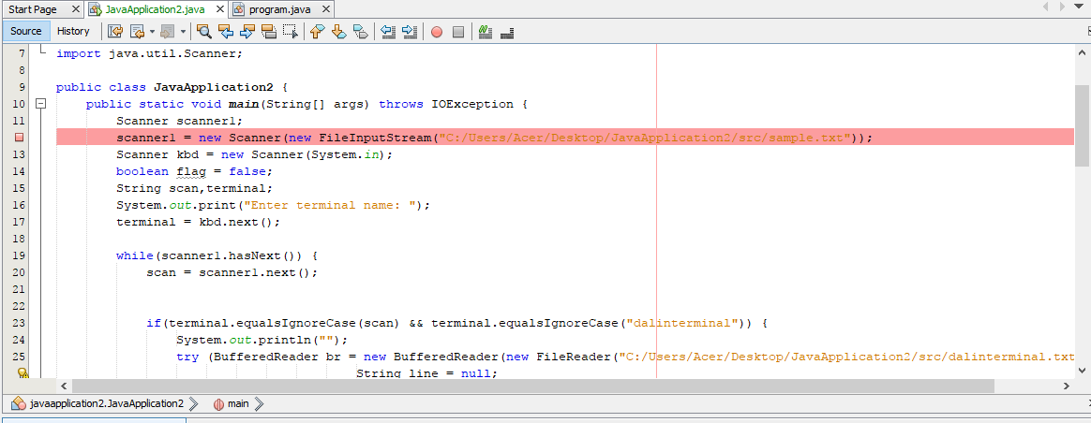

Start debugging session

• Click on the menu tab and then choose Debug and click on Debug file
• Once clicked on debug button its color will turn to green
• At the lower part a debugger console will appear where it will show the line breakpoint, the variables declared and other information to be used during the debugging session
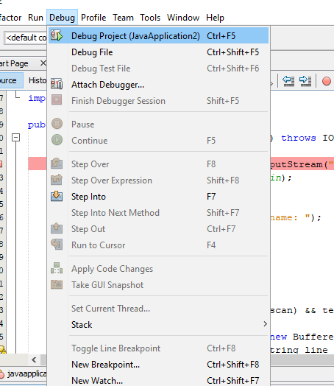

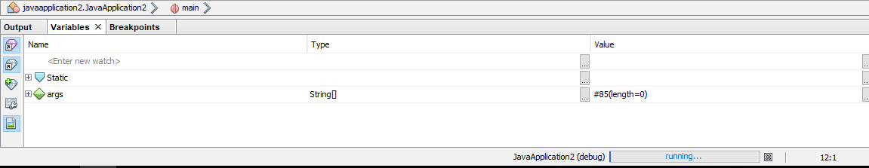

Step over(F8)

• Step over will view the input parameters and the resulting parameters then proceed to the next method
• Clicking on step over would change the color of the breakpoint and the next line would turn green
• The parameters of the next line would appear on the debugger console

TOPIC 5 - JAVA DOCUMENTATION
- Documentation is where we put every detailed functional information for the read to learn and guidelines for the user. In programming we used documentation to document our program for easier to understand and for future purposes. Documentation is also written to support any activity. Javadoc is a tool that NetBeans uses for documenting java. Javadoc documentations are being generated to HTML form. Under Javadoc we have a “doc comment”, the doc comment is where we place the description, function, explanation for the block or lines of codes.
- Documentation generator made by Sun Microsystems for the Java dialect (now claimed by Oracle Corporation) for creating API documentation in HTML arrange from Java source code. Javadoc does not influence execution in Java as all remarks are evacuated at accumulation time.

JAVA Documentation Using NetBeans IDE
Sample of doc comment

JavadocComment
- it is the place we locate the general portrayal, label marks with information.

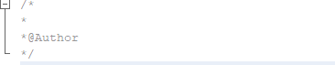

Block Comment
- this remark we can discover the depiction for the class and others.
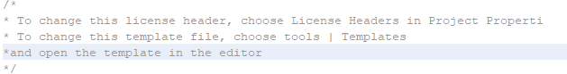

Inline comment- ignores everything to the end of the line
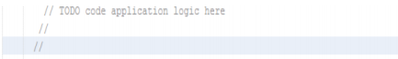

Generate Javadoc documentation-
- creates a Javadoc to the Javadoc organizer in your catalog at that point opens the documentation in the assigned program.
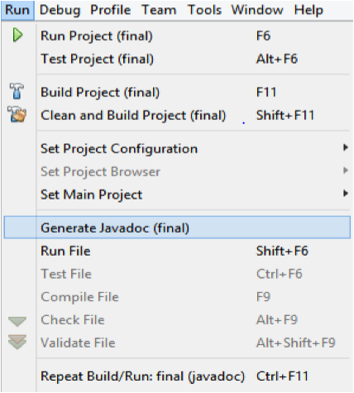

Auto generate comments in the file
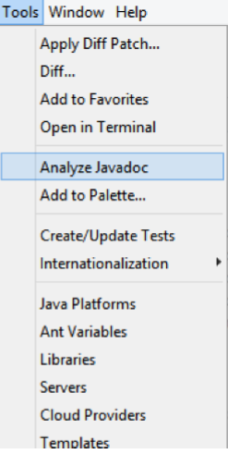
Step 1:

Click on tools in the navbar and select “Analyze Javadoc”

Step 2: Then check all the files
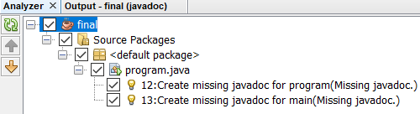

Step 3: Click on Fix selected to apply the changes
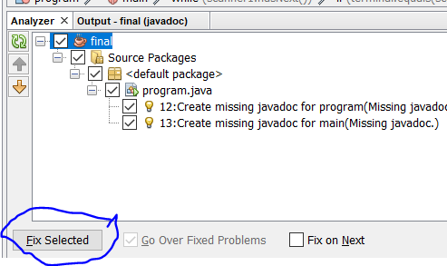

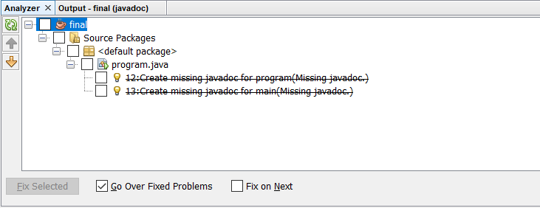

References

